# Article Voting User Guide

## Installation

Loging into the Wordpress backend and go to Plugins. Find the plugin “Article Voting” and active it.



## How To Use

Once activated, it will show automatically below the post content for single post articles.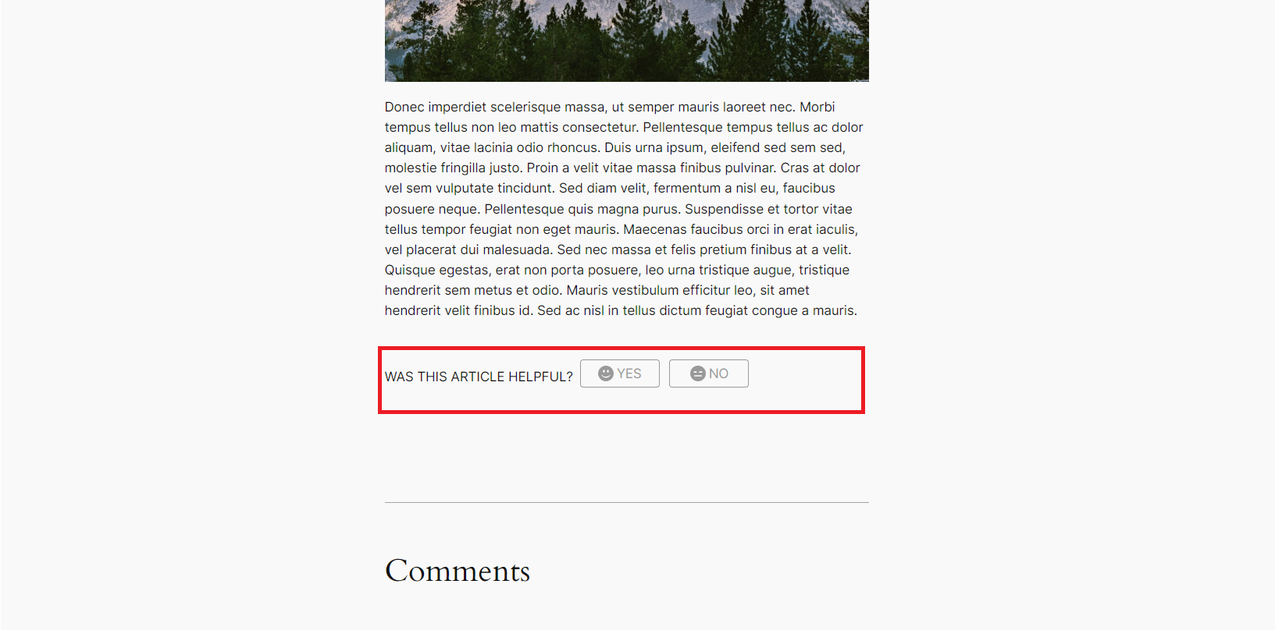

If the user votes, it will hold up the voting data in the post meta table in the database via, and will show the result, and what he voted on refresh.

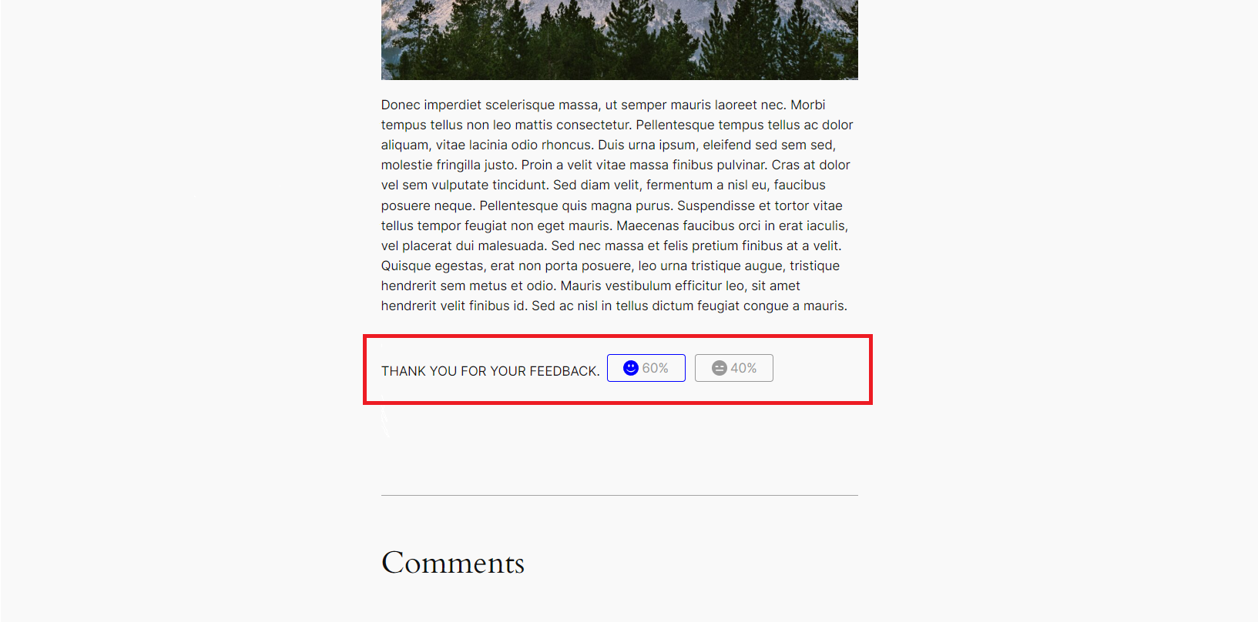

## Additional Functionality

In the backend the plugin enables a new meta box for Post post_types that shows the result of the voting. This is show in the sidebar, below discussion.

